Chateau Chien Dog Training

Jeannette LaMonde is the owner of Chateau Chien, a business that offers dog training for new pet owners, or for those who need to teach an older dog some new tricks.

A site map for the company website is shown below. The site map describes the architecture of the website, which consists of the “Home” page with three main content pages: “Classes,” “Schedule,” and “Contact.”

A wireframe sketch of the first draft page layout for the website follows. The HTML and HEAD are important for proper page rendering, but are not visible in the main browser area. The BODY contains the elements that are displayed in the browser window. It contains a HEADER with the company name and/or logo, the NAVigation links, the MAIN content of the page and a FOOTER element for copyright information.

HTML

HEAD

BODY

FOOTER

HEADER

NAV

MAIN

**Tasks in this case study:**

1. Create a folder for the website.
2. Create an html file with the basic structure for all of the pages in your site
3. Create an initial .css file for all of the pages in your site.
4. Add page responsiveness into your html and css files.
5. Upload your files to a web server

# Hands-On Practice Case Study

**TASK 1:** THE WEBSITE FOLDER. Create a “root” folder on your device to contain your web page files. It doesn’t have to be named “root” -- use a descriptive name that tells you what it is, and store it in a location you can find easily. Inside the folder, create two additional folders: a “stylesheets” folder and an “images” folder. Some of your learning material also uses a “resources” folder. This is important for large complex sites, but is optional in this class. The folders for images, stylesheets are not optional.

**TASK 2:** THE HTML ELEMENTS. Use your text editor/IDE to create a file that contains the elements/tags shown in the wireframe above. Be sure they are properly nested! For a quick review of nesting elements see <https://www.w3schools.com/html/html_elements.asp>

1. The **<head>** generally contains ( among other things) the title of the web site to be shown browser's title bar or in the page's tab. Nest the <title> element properly, so that “Chateau Chien” will display.
2. The **<header>** (Careful! The <HEAD> and <HEADER> tags are NOT the SAME things!) will generally contain the typical site “banner” with things like the company logo to be shown on every page. For now, just put the company name in this tag. Use the <h1> tag to make it stand out.
3. The **<nav>** will contain the navigation links to other pages in the site. You will learn how to make links work soon. For now, just add text to represent the tags – one name for each page in your site map.
4. In the **<main>**  section add an **<h1>** greeting, and two simple paragraphs shown in Figure 1 below using <p> elements. Use an **<h4>** heading for the first address line, then use **<br>** to provide line breaks for the other address lines.
5. Add the **<footer>** area with the copyright and email text shown at the bottom of the page also shown in Figure 1.
6. Save your file as “index.html”. Be sure there is no other file extension on the file. You will find it helpful to change your computer’s setting to ALWAYS display the full filename, including the file extension. Most operating systems “out of the box” will hide the file extensions on your desktop and in your file browser, but it is better if you can see them clearly. How to change the settings will vary with the O/S version you have. Google can come in very handy for finding out how to change this setting on your machine. View your work in your browser to make sure it renders properly. It should look like Figure 1 below.

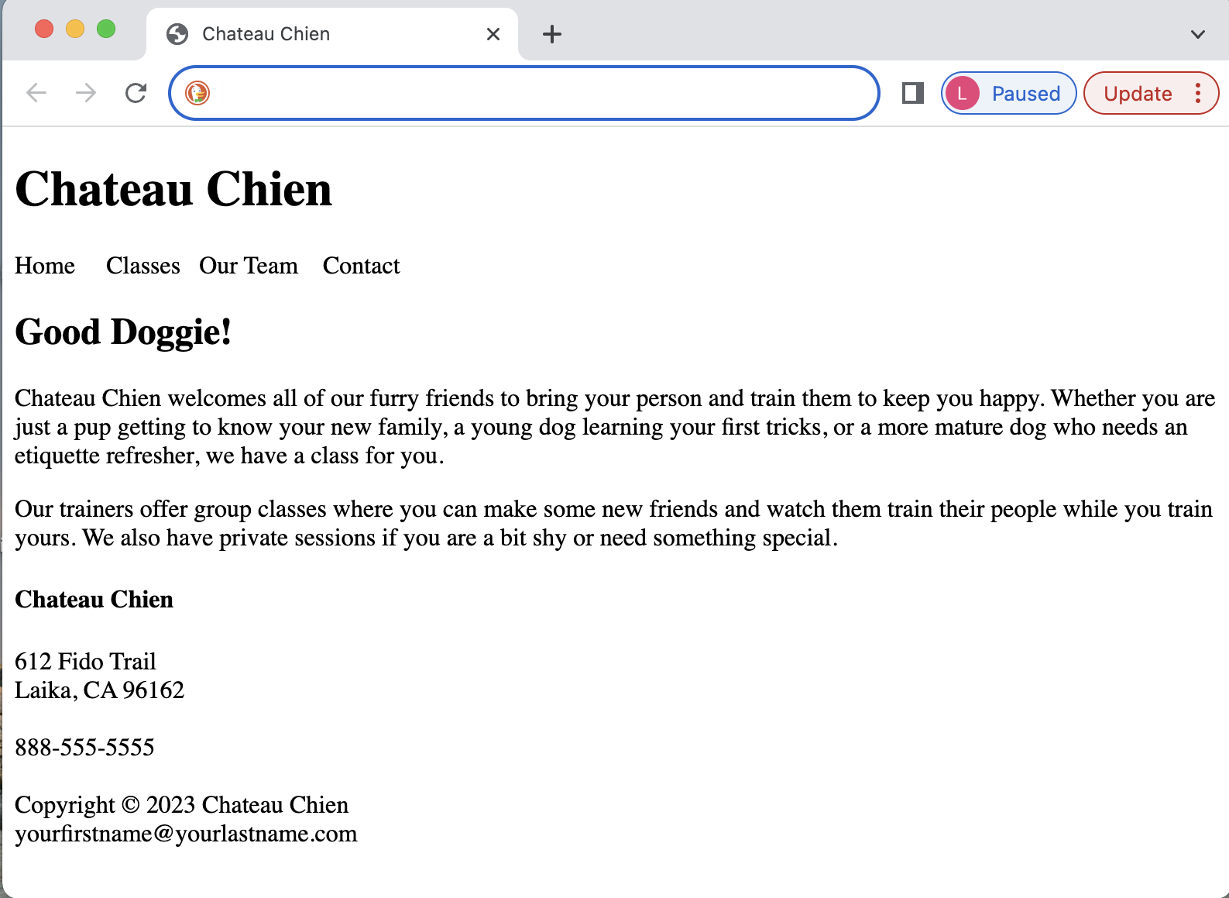

Figure : Basic HTML

1. **Add appropriate comments** to your code and validate it at <https://validator.w3.org/>

**TASK 3**: THE CSS FILE. To add flair to you page you need color, font styles and many other design features. For now, you are just setting up a few basics, so the styles you use will be limited – just background and fonts for now. More will be added in the next assignment. This should be done using an EXTERNAL stylesheet.

1. Use your text editor/IDE to create another file called “Chateau.css”. This will be your external stylesheet. Make sure the .css file extension is properly used. You do NOT want the .html or a second .css file extension appended to the file when you save it.
2. Save the CSS file in the “stylesheets” folder.
3. Link your HTML and CSS files. In your HTML template add the link to the external css file. Put the <link…> tag in the <head> ( not the <header>) Use the name of your new CSS file. **Correct pathing in the name is important!** Include the Stylesheets folder name in the path.
4. Best practices today suggest that in many cases, designing for mobile devices FIRST, then adapting your design to larger screens is the more effective approach. Therefore, you will start with “default” css rules for small screens. In your css file, add a rule for the *body* selector to use the background color **DodgerBlue**. Refer to <https://www.w3schools.com/cssref/pr_background-color.php> for the syntax of the background color rule. Use another rule to make the font color **White** to give the lettering good contrast. Remember, this is in an external stylesheet, so you do not use the <styles> tag – just list the rules in your .css file. Use the *main* selector to make the content area **White** with **Navy** text color. Also use a san-serif font-family (like Arial) for the body text.

**TASK 4:** ADD RESPONSIVENESS

1. In the <head> use the <meta> tag to set the viewport. Refer to <https://www.w3schools.com/css/css_rwd_viewport.asp> This will allow the user’s device’s size to be detected when the page is rendered.
2. Now you can style the larger screen. To make your stylesheet responsive add a media query for larger screens. Refer to: <https://www.w3schools.com/css/tryit.asp?filename=trycss3_media_queries1> Add rules to give the *body* selector a background color of **LightSkyBlue**, and text color of **Navy.** For the contrasting banner at the top of the page add rules for the *header* selector – the background color is **DodgerBlue** and the text is **Snow.** Use a serif font family (like Georgia or Times New Roman) for the *body* text. Since the <main> area is going to be the same white background and navy text as the mobile version, you don’t have to repeat rules for this element – the default at the top will also apply to the @media query screen size.
3. View your page in your browser to make sure the CSS file is properly linked, and that the background color and font changes properly when you resize the browser window. Refer to Figure 2.
4. Add appropriate indentation and comments to your code and validate it at <https://jigsaw.w3.org/css-validator/>

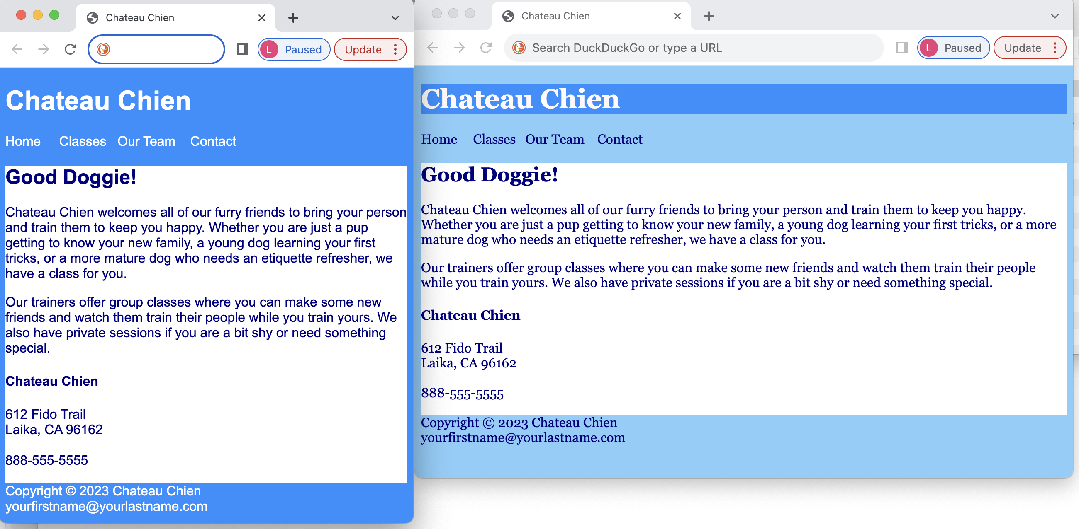

Figure : Responsive template. Left side is the small screen, right side is the large screen

**TASK 5:** UPLOAD the page to the web server.

1. Use Filezilla or your preferred FTP client to move the files to your server account.
2. Use the full URL for your Azure account to display your page.
3. If needed, correct any typos or tag errors on your local machine, (you cannot edit on the server) and then replace the files on the server. Remember you may need to refresh your browser when you try to view it again.
4. Zip your file structure for submission to Canvas. Include screenshots of your validation results in what you submit.

**HTML resources:**

Morris: Ch 2 thru 2.9 breakpoints, and 2.15 Special Characters – 2.16 structural elements

<https://www.w3schools.com/html/default.asp> HTML HOME

<https://www.w3schools.com/html/html_intro.asp> HTML Introduction

<https://www.w3schools.com/html/html_editors.asp> Html Editors

<https://www.w3schools.com/html/html_basic.asp> HTML Basic structure

<https://www.w3schools.com/html/html_elements.asp> tag structure and nesting

<https://www.w3schools.com/html/html_headings.asp> headings

<https://www.w3schools.com/html/html_head.asp> HTML HEAD element

<https://www.w3schools.com/html/html_comments.asp> HTML Comments in the code

<https://www.w3schools.com/tags/default.asp> HTML Tag reference

**CSS resources:**

Morris Ch 3 thru 3.2 on color

<https://www.w3schools.com/tags/tag_link.asp> HTML link to CSS file

<https://www.w3schools.com/css/css_howto.asp> includes external stylesheet link

<https://www.w3schools.com/css/css_syntax.asp> CSS Rule structure

<https://www.w3schools.com/css/css_comments.asp> CSS Comments in the code

<https://www.w3schools.com/css/css_colors.asp> CSS named colors

<https://www.w3schools.com/css/css_colors_hex.asp> CSS hex colors

<https://www.w3schools.com/css/css_background.asp> background color rules

<https://www.w3schools.com/css/css_text.asp> CSS Text colors

<https://www.w3schools.com/cssref/index.php> CSS Property reference

**Responsiveness resources:**

Morris Ch 7.5 – 7.7 on media queries, with image and link examples

<https://www.w3schools.com/css/css_rwd_intro.asp> What is responsive?

<https://www.w3schools.com/css/css_rwd_viewport.asp> Viewport HTML tag

<https://www.w3schools.com/css/css3_mediaqueries.asp> Media Queries